Lab 4 - Manage personas and custom security roles in Dynamics 365 Contact Center
Duration: 10 mins

Introduction
In this lab, you will learn how to access and manage role persona mapping in the Copilot Service admin center. Role persona mapping allows administrators to assign or modify security roles for different personas, such as agents, supervisors, or admins, to control access levels and permissions within the system.
Task 1: View and Edit Role Persona Mapping
In this task, you will navigate to the Role Persona Mapping section, view available personas, and explore how to add or remove security roles. Although no changes will be made in this lab, this task demonstrates the process for managing persona-based security roles.
- On the left navigation pane, select User management in Customer support again.
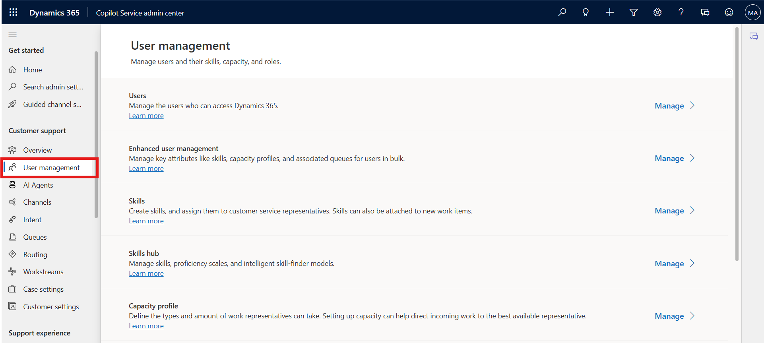
- Select Manage for Role persona mapping.
- 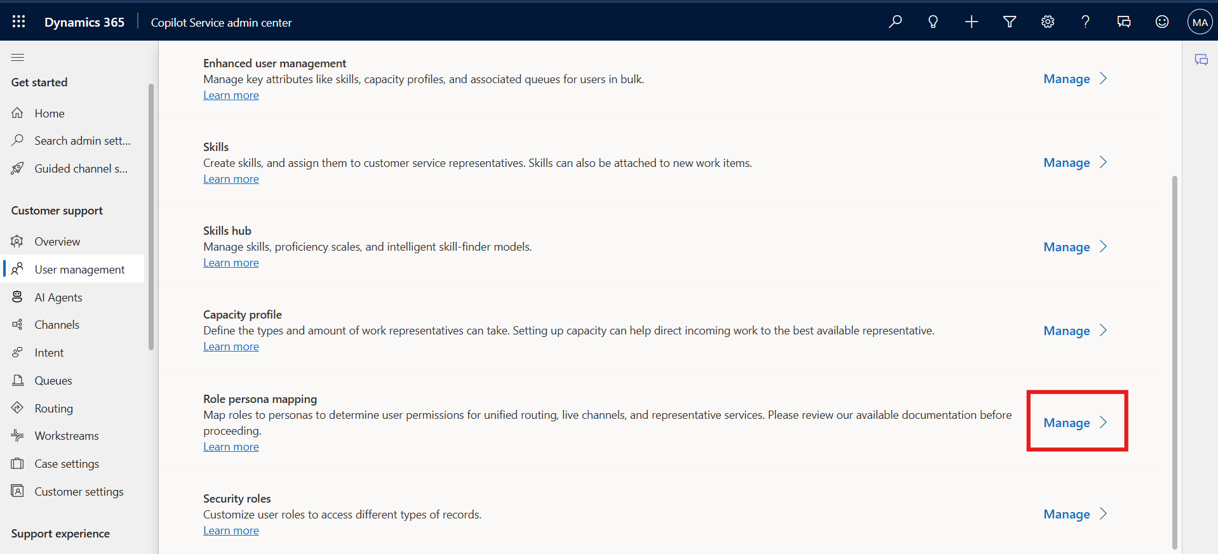
- Select the persona – Admin to add or remove security roles. The Edit roles pane displays the list of roles.
- 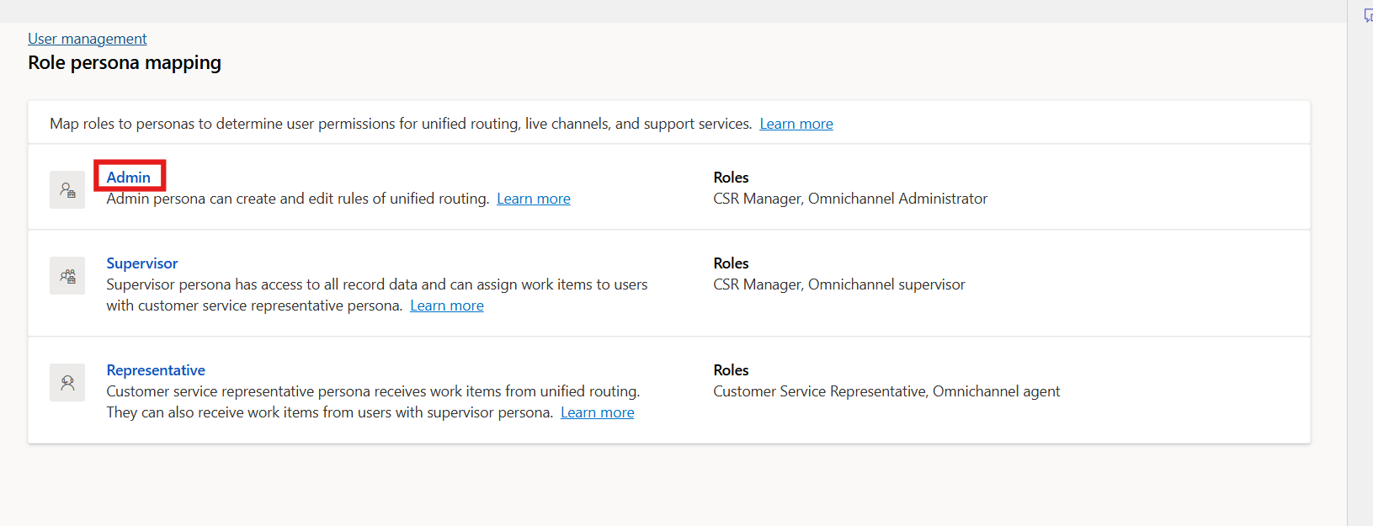
- Select or clear the selection from the checkboxes for the required security roles.
- 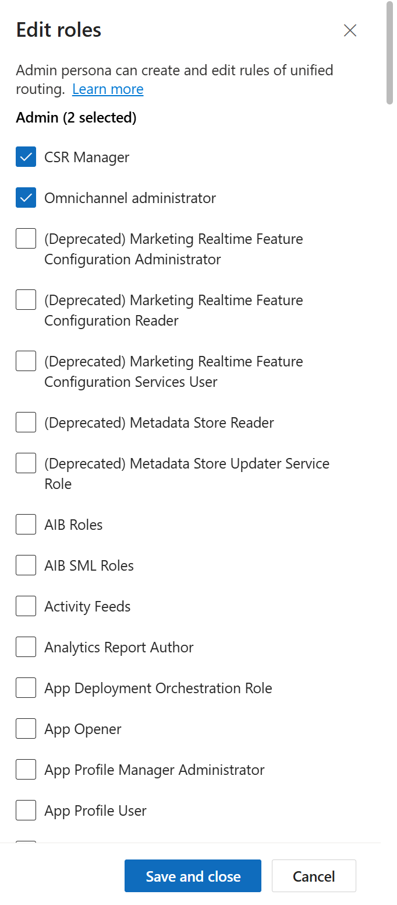
- Note – For this lab, we are not adding or removing any roles for the persona.
- Select Save and Close after you have made any changes.
- 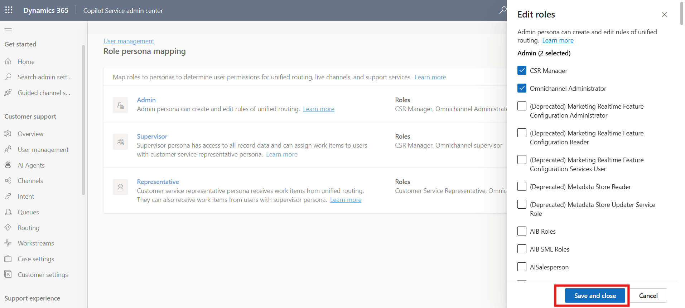

Conclusion
By completing this lab, you have learned how to access and manage role persona mappings in the Copilot Service admin center. Understanding this feature helps administrators ensure that users have the appropriate permissions and access levels based on their roles.

